PTKM-1R Russian top attack mine

Jip McTavish-Foxall

The PTKM-1R is a Russian high explosive, top attack, shape charge, anti-tank land mine. First unveiled in November 2021 it is one of Russia’s newest and most technologically advanced anti vehicle mines. It was adopted by the Russian ground forces in limited use in summer 2020 although it is believed it had started to appear in Russian based media in 2017. Its first recorded combat use was in April 2022 in Kharkiv oblast Ukraine. It is manufactured by PAO Zavod im. G. I. Petrovskogo based in Nizhny Novgorod, Russia.

The acronym PTKM-1R stands for Противотанковая противокрышевая мина, the literal translation is anti tank anti roof mine, the R designation stands for ручного which means manual emplacement.

It is sometimes referred to as TEMP-30, whether the PTKM-1R was developed from the TEMP-30 is unknown. TEMP-30 was an earlier Russian development of a top attack mine based around the motor of an S5 rocket. It was developed by Gosudarstvennyy Kazennyy Nauchno Ispytatel’nyy Poligon Aviatsionnykh Sistem based in Moscow, they have also developed the TEMP-20/PVM anti helicopter mine with similar acoustic and infrared sensors.

Purpose of the PTKM-1R

The PTKM-1R is designed for manual mining of terrain for the purpose of destroying tanks and other armoured vehicles from above. It was designed to disable the combat capabilities of an M1 Abrams tank or comparable western MBT for a period of at least 3 hours within a specific engagement envelope.

Main technical and tactical characteristics

Type Manually emplaced top attack shape charge
Fuzes Mine, 4 acoustic sensors around the top of the mine, Seismic detector. Combat Element, infrared and radar sensors

Mass 20kg
Explosive mass 2.8kg
Dimensions mm
Height 515
Diameter 181
Overall body size 220

Maximum engagement range 50m
Minimum engagement range 5m
Target speed 5-50 km/h
Armour penetration <100mm

Arming delay
Electronic 300 seconds
Mechanical minimum 50 seconds
Self destruction time
Complete mine 1 to 10 days
Combat element after launching 4.5 seconds

Operating temperature -40 to +50
Shelf life 10 years
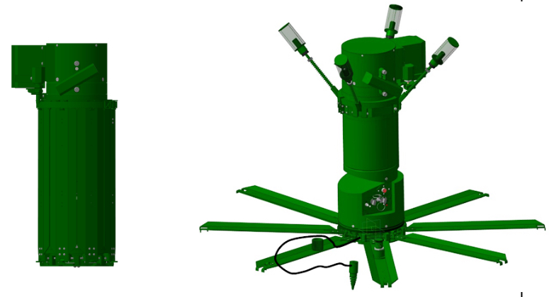
Figure 1 Figure 2
Anti tank mine PTKM-1R in traveling position (fig. 1) and armed position (fig. 2)

6

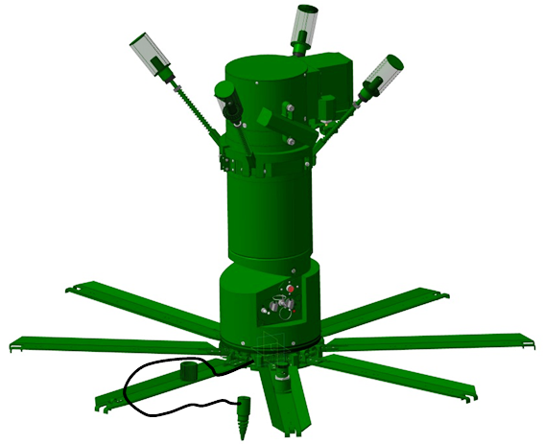
2
1
5
3
7
4

Figure 3
9

8

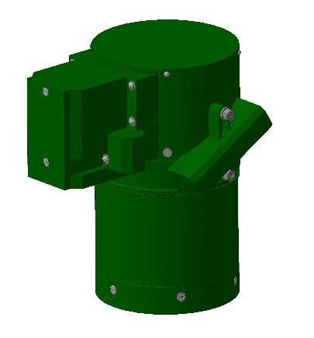
11
10

Figure 4

PTKM-1R in armed position (fig 3) Combat element after being launched from the barrel (fig 4)
- trigger unit housing
- Warhead/combat element
- 8 legs for stability
- Arming pin
- Seismic sensor
- Acoustic sensors
- Barrel
- Infrared sensor
- Fuze
- Shape charge
- Rocket motor

The PTKM-1R consists of a transport and launch platform and the shape charge combat element. The transport and launch platform is designed to detect the target with acoustic and seismic sensors, tilt the mine toward the target and launch the combat element.
It consists of fuze device with a battery power supply, a seismic sensor, rotary platform, piston and powder chamber. Figure 3.
Figure 4 the combat element, designed once launched to be guided by radar and infrared signature of the target vehicle. It has two motors to induce spin into the warhead to help the radar scanning and target acquisition.
The combat element is launched on a ballistic path that intercepts the target. When the combat element is above the target the explosives detonate forming a projectile from the copper cone with a velocity of 2800 metres per second. This penetrates up to 100 mm of armour according to the manufacturer although other soursces say 70mm. The outcome on the target vehicle will depend upon the area struck, from a fire power kill, a mobility kill or even more catastrophic k-kill. Obviously the top area of an armoured vehicle being the most vulnerable.

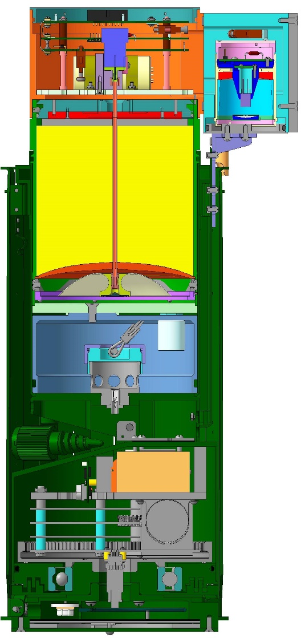
8
1
10
9
7
2
4
3
5
6
1. Fuze
2. Battery
3. Seismic sensor
4. Rotary platform and gear box
5. Piston
6. Launch charge
7. Barrel
8. Legs folded
9. IR sensor support bracket
10. Warhead/combat element
10
1
10
8
4
3
5
6
7
9
2

- Fuze
- Firing mechanism incorporating a self destruct element and mechanical safety
- Battery
- Radar sensors
- Infrared sensor
- Warhead housing
- Explosive charge
- Copper cone/Explosive formed projectile lining
- Asymmetrically mounted rocket engines
- Rocket motor

Trigger unit and arming sequence

The trigger unit of the mine is designed to carry out self serviceability checks using the button marked 1, the target is set using the switch labeled 3, currently it is uncertain what these settings equate to but it is believed it may be a target counter letting a certain number pass before attacking the designated number, the switch labeled 4 sets the self destruction time of the mine from 1-10 days.

5
3

4
7
6
2
1

- Status check button
- LED arming indicator
- Target setting switch
- Self destruct time switch (days maximum 10)
- Safety pin
- Arming pin
- Mine trigger unit
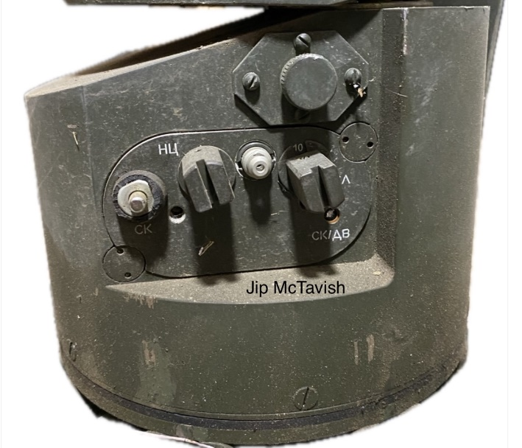

Safety mechanism

The safety mechanism 1 in the combat element/warhead is designed so that when shear pin 4 is in place it blocks the path of the fire train from the electric ignition 5 to the detonator 6. On the shearing of pin 4 spring 3 pushes on the charge housing 2 causing the booster charge 7 to line up with detonator 6.

1

2
7
6
3
5
4

Principles of operation of the PTKM-1R

After emplacement in the firing position and arming the PTKM-1R goes into standby mode. Vehicles can be detected at a minimum range of 100m using the seismic and acoustic sensors depending on ground conditions. When a target is determined the PTKM-1R goes into combat mode. Safeties are removed and the mine calculates the lead angle required for the trajectory of the combat element/warhead and is tilted and angled accordingly for optimum “meeting point” of the explosive formed projectile and intended target.
Upon launch with a muzzle velocity of 30 metres per second, the two engines on the combat element are ignited inducing spin around its off centre axis, the spin allows for efficient use of the radar and infrared detector to scan the ground for the target.
When the target is detected the fuze sends an electrical signal to the detonator in the safety mechanism to detonate the explosives forming a projectile from the copper lining of the shape charge of the warhead.

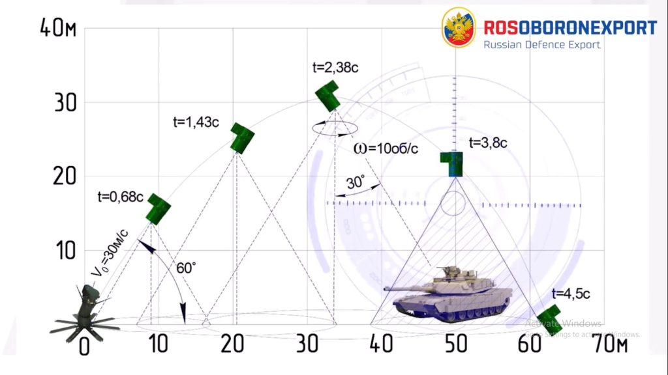
This graphic from the Russian MOD shows the trajectory of the combat element from leaving the launcher to maximum range. Maximum height reached by the combat element is 30m.
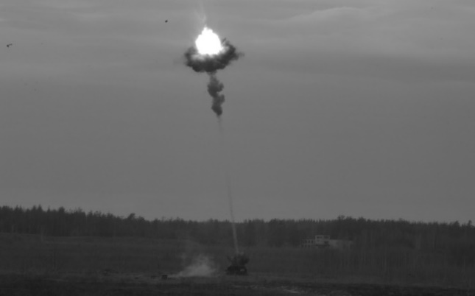
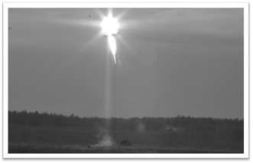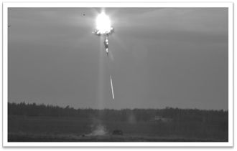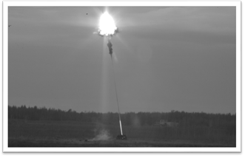
The photos show the formation of the EFP after the detonation of the explosives in the combat element.

SAFETY!

After installation do not move the mine. The smart fuze has an anti handling feature. Any attempt to move the mine, remove the combat element, change the settings on the trigger unit will lead to the self destruction of the mine. 10 degrees tilt is all it takes for activation of the self destruction mechanism. PTKM-1R should be destroyed in situ. Any disarming attempt will result in the self destruction of the mine. It is unknown if the antihandling capabilities of the mine are still active in the case of failure of the preprogrammed self destruct.

Installation instructions

Installation is carried out by a two man team. The PTKM-1R comes prepackaged in its transport crate with everything required for installation. The shipping crate contains 6 pieces of ballistic armour rated to 12.7x108 Armour Piercing Incendiary Tracer according to seized Russian documents. This also reflects the high regard and high cost of the PTKM-1R within the Russian ground forces. On opening the shipping crate the upper most armour must be removed using the spanner/wrench attached to the inside of the lid of the crate. The spanner/wrench is held in place with two wingnuts. Cut the bag open and remove the mine from the crate with the two straps provided. Standard operating procedure from the Russian manual is to check the mine at this stage for defects or damage and if any defects are found dispose of the mine. The covers for the acoustic sensors should also be removed from the transit case and placed in the bag with the mine.

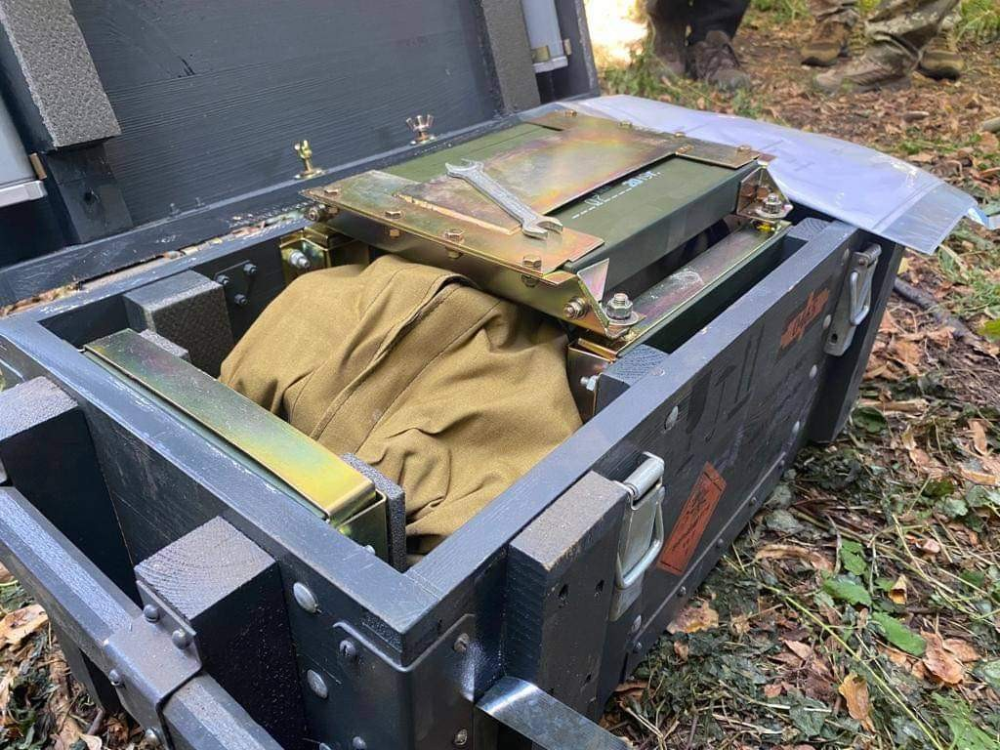
This PTKM-1R was found in Kharkiv Oblast 10 September 2022. Note the armour plate on top and the end of the shipping crate. There are 6 in total. Also visible is the spanner/wrench for the removal of the armour plate to access the mine and the two wing nuts that secure it in place from the factory.

The PTKM-1R requires a horizonal site of at least 1mx1m cleared of all snow, stones, branches and any other foreign objects. Any vegetation, bushes or trees in the vicinity of the site should be checked to ensure they do not interfere with the intended flight path of the combat element/warhead. The mine is unsuitable for use on soft ground or snow. In snowy terrain the snow cover should be removed down to solid earth. The mine should be installed with the acoustic sensors above the snow line.
After a suitable site is chosen for the PTKM-1R as one crew member removes the mine from the transit case the other prepares the site digging a 50-100mm small hole for the installation of the seismic detector.

The following operations are then carried out.
- Remove mine from the bag
- Install the mine in a vertical position on the ground
- Remove the locking ring releasing the legs at the base of the mine and the four acoustic sensors at the top of the mine
- Lock the legs into place
- Place the covers over the acoustic sensors
- Unscrew the seismic sensor from the leg
- Place seismic sensor in the predug hole ensuring a tight fit between the earth and the tip of the sensor.
- Cover the seismic sensor with earth and compact, taking care not to damage the sensor wire
- Press the self checking button on the trigger group for 10 seconds. The light should stay illuminated for the first 3 seconds, then flash on and off in one second intervals. If a malfunction is detected the light will stay lit.
- If a malfunction is detected the mine should be destroyed
- The self destruction time in days 1-10 and the target type 1-10 must now be set
- When installing the mine the “Towards Target” arrow on the cap should be oriented toward the likely direction of the appearance of the target armour.
- The safety clip is now removed followed by the arming pin
- SAFETY It is now impossible to return the mine to an unarmed safe state
- The СК/ДВ SK/DV light lights up indicating the mine is arming. This stays illuminated for 240 seconds +-24 seconds
- The electronic safety timer on the fuze starts 300seconds
- At the same time the mechanical shear pin is pulled allowing alignment of the electrical firing components. This is a 50-300second delay depending on environmental factors
- The crew must vacate the vicinity of the mine before the mechanical delay expires
- Standard time from deployment at the site until the PTKM-1R is emplaced and armed is 7 minutes.

Demolition procedure

*These procedures come from a translation of the Russian PTKM-1R manual

The armed PTKM-1R should not be moved! It should be destroyed in situ by explosive means or through the use of small arms. If using explosives a 400gram charge is used with an electronic detonator placed directly on the upper cover of the warhead. The danger radius is quoted at 500m. The manual also suggests it may be possible to destroy the mine using small arms from the confines of an armoured vehicle or appropriate shelter. Presuming the armoured vehicle is outside of the engagement envelope!

Real world use

First spotted in Ukraine in April 2022 the FENIX insight OSINT search only has two geolocated uses of the mine once in Kherson in February 2023 and once in Zaporizhia in November 2022. Looking at videos posted to social media of PTKM-1R by Russian sources they are very careful to hide any evidence of location. Its use is more common than is being reported.

Speaking to people working in Ukraine they were semi common in 2022 but became more widespread in the counter offensive of 2023. Newer versions are purportedly to be much more combat effective than the earlier version. Older versions with dates 2018/19 seemed to suffer from failure of the self destruct. But newer version “1. works just fine in engaging armoured targets 2. The self destruct actually works now”

“we do not know if the new production models have any change of physical characteristics or if it is just a software upgrade based on combat experience”

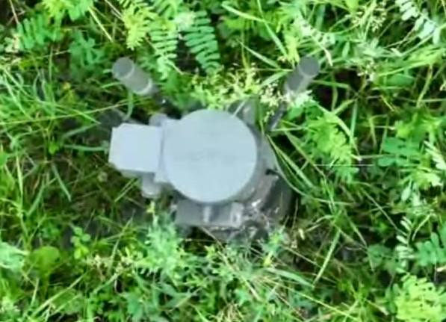
This photo from Telegram purportedly taken by a drone and published on 23rd June 2023 shows that despite its significant size it is possible for the PTKM-1R to be quite easily camouflaged amongst vegetation.
The screen shots below are from a video posted in February 2023 on twitter they show three PTKM-1R set up adjacent to a road in an ambush position. All the mines have fired or self destructed although it is a short clip there is no destroyed or damaged armour in the video. This follows standard emplacement doctrine for these mines not just as stand alone weapons but as part of mixed mine fields and defences.
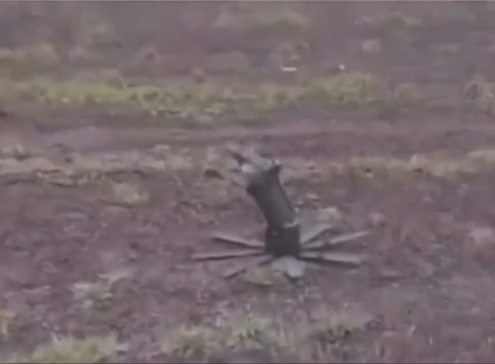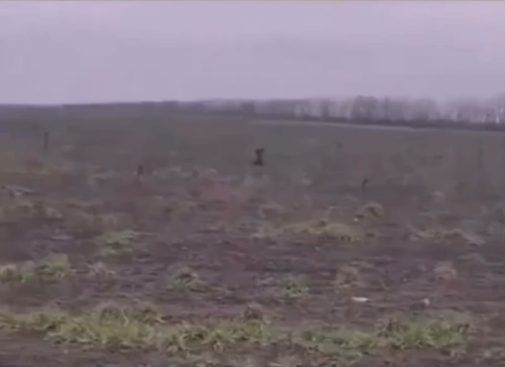
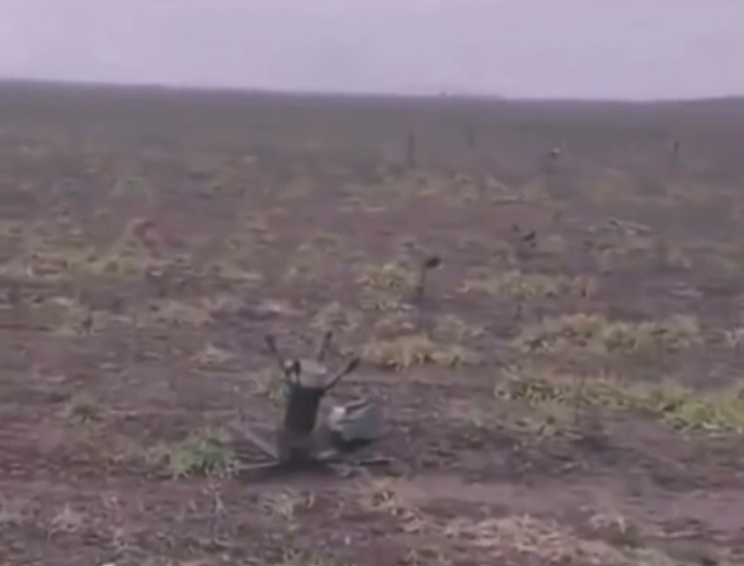

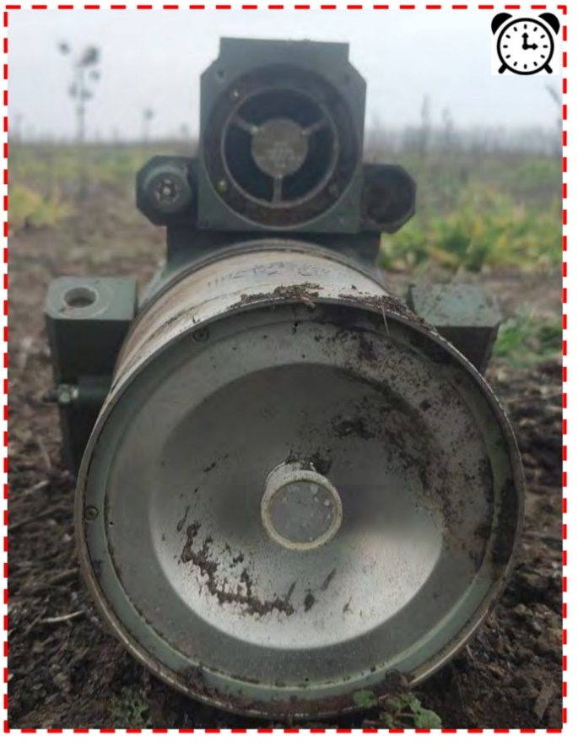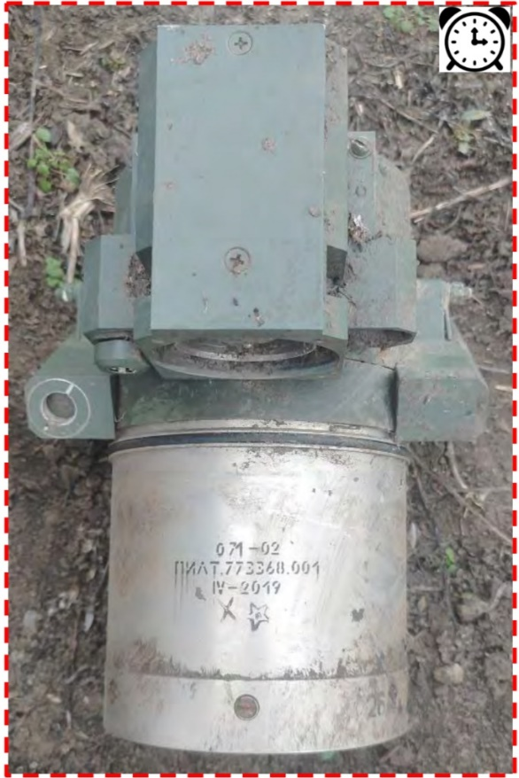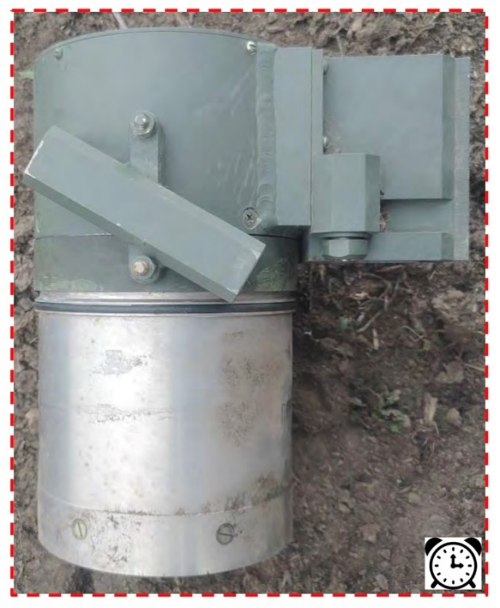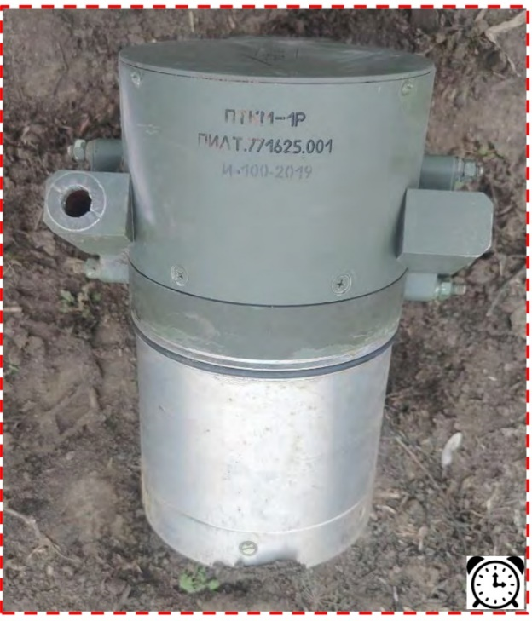

These photos taken by EOD police in Ukraine and sourced from the Basic Identification of Ammunition in Ukraine. What is notable is the failure of one of the rocket motors. It is of 2019 production so pre military adoption. These have had high failure rates with the self destruct. Indeed early on in the conflict these were seen as an over expensive joke but new production models have overcome some of these early failures.
Actual combat use of the PTKM-1R is still heavily guarded both by the Russians and the Ukrainians. Units engaged by a PTKM-1R are usually too busy to be taking photos. It is also entirely possible that use of the PTKM-1R is attributed to drone strikes/drone dropped munitions punching a hole in the roof of a vehicle rather than a top attack mine. There are videos of vehicles being attacked with drones and none that I can find of PTKM-1R engaging any target except for the Rosoboron Export videos released to coincide with the unveiling of the PTKM-1R at EDEX 2021 thus units engaged by an unseen top attack munition will be more naturally inclined to attribute it to drone attacks.

Thanks for reading, you can reach me at Jip_Mctavish@yahoo.co.uk

References

www.fenixinsight.online

Tony @ Bomb Techs Without Borders

National Police of Ukraine EOD service

State Emergency Services of Ukraine EOD

8th Special Forces Explosives service

Markian @ PREVAIL

Ivan Kocin

